“Basic Weather App”
A project report submitted to
SOURASHTRA COLLEGE
(Autonomous)
Submitted In the partial fulfilment of the requirement for the award of the degree
BACHELOR OF SCIENCE IN INFORMATION TECHNOLOGY
SUBMITTED BY
T.G.VENKATESH BABU (21UIT011)
Under The Guidance Of
Asst.prof.R.P.Umadevi B.E.,M.B.A.,

SOURASHTRA COLLEGE
DEPARTMENT OF INFORMATION TECHNOLOGY
(Autonomous)
(AFFILIATED TO MADURAI KAMARAJ UNIVERSITY
RE-ACCREDITED BY NAAC WITH ‘B+’ GRADE)
PASUMALAI , MADURAI - 625004
April 2024

SOURASHTRA COLLEGE
DEPARTMENT OF INFORMATION TECHNOLOGY
(Autonomous)
(AFFILIATED TO MADURAI KAMARAJ UNIVERSITY
RE-ACCREDITED BY NAAC WIYH ‘B+’GRADE)
PASUMALAI, MADURAI-625004
2021-2024
BONAFIDE CERTIFICATE
This is to certify that the project entitled “Basic Weather App” was done by T.G.VENKATESH BABU(REG.NO.21UI011) in the Department of Information Technology, Sourashtra College under the guidance of Asst.prof.R.P.Umadevi B.E.,M.B.A., It is submitted in partial fulfilment of requirement of Sourashtra College for the Degree of Bachelor of Science in Information Technology during the year JUNE 2021-APRIL 2024.

Internal Guide Head of the Department
Submitted for the VIVA-VOCE examination held in the department of Information Technology of Madurai Kamaraj University at Sourashtra College held on………….

Date: External Examiner

ACKNOWLEDGMENT

ACKNOWLEDGMENT

There are several people behind us, without them this project has not been make possible. We have to thank those people unfailingly.
I thank our principal Prof.Dr.K.R.SRINIVASAN M.A(Hons),M.Phil,M.B.A,M.Phil(mgt),ph.D,D.P&C.S.,C.L.I.Sc., for having given under section the prestigious opportunity of begin the member of this institution.
I extend my hearty thanks to our Head of the Department Asst.prof.R.P.Umadevi B.E.,M.B.A of Information Technology for timely advices and her efforts to clear doubts and fear of completing this project successfully.
I thank my beloved parents for providing us all the requirements immediately whenever I want. Above all, I thank all our dear friends for the immeasurable help and support rendered by them during this project work. I thank the almighty god for giving us physical and mental strength and ability for the effective completion of this project.

DECLARATION

DECLARATION

I, T.G.VENKATESH BABU(REG.NO.21UIT011) Bonafide student of the department of Information Technology, Sourashtra College Madurai., hereby declare that the project work entitled “BASIC WEATHER APP” Submitted by in partial fulfilment of the requirement for the award of the degree of bachelor of Information Technology, Sourashtra College(Autonomous) affiliated to MKU in our original work. This project is originally prepared by us and carried out under the guidance of our staff Asst.prof.R.P.Umadevi B.E.,M.B.A Sourashtra college, Madurai for the award of Bachelor of Information Technology.

Place: By

T.G.VENKATESH BABU
Date: (21UIT011)

Basic Weather App

ABSTRACT

Weather prediction for the future is the most important for getting the information about the climate so far used for the agriculture sector. The purpose of this research is to forecast parameters that could assist farmers in making well-informed decisions in order to minimize losses by implementing the necessary preventative actions. A machine learning method has been created for the purpose of effectively identifying or forecasting the weather. Additionally, the system is created with machine learning algorithms like KNN and Logistic Regression. Accuracy, precision, recall, f1-score, ROC curve, and confusion matrix are all demonstrated by the experimental outcomes. Here we find some of the weather conditions to get the season timings. Deploy the output and pickle format for getting the output in a web application format used by a python default package streamlit.

TABLE OF CONTENTS

CHAPTER | TITLE | PAGE NO
1 | INTRODUCTION
2 | SYSTEM STUDY
3 | SYSTEM ANALYSIS
4 | SYSTEM SPECIFICATION
5 | SOFTWARE DESCRIPTION
6 | SYSTEM DESIGN
7 | SYSTEM TESTING
8 | SOURCE CODE
9 | SAMPLE SCREENSHOT
10 | CONCLUSION
11 | FUTURE ENHANCEMENT
12 | BIBLIOGRAPHY

CHAPTER 1

INTRODUCTION

  - General Introduction:
Weather forecasting is an essential yet challenging task, intricately managed by meteorologists. By providing insights into upcoming weather conditions, forecasts enable individuals and industries to plan their activities effectively. Sectors such as agriculture heavily rely on accurate predictions to optimize crop management and mitigate potential losses due to adverse weather events.
Various techniques and algorithms are employed in weather forecasting, ranging from traditional methods to modern machine learning models. For instance, models like Auto Regressive Integrated Moving Average (ARIMA) and Long Short-Term Memory (LSTM) are utilized to predict temperature changes, aiding farmers in early disease detection and crop management.
Predictive models typically integrate meteorological variables, historical data, and sometimes a combination of both to enhance accuracy. The forecast horizon, whether short-term or long-term, significantly impacts model performance, as does the spatial scale of predictions.
Weather forecasting is inherently complex due to the dynamic and chaotic nature of atmospheric processes. Meteorologists leverage scientific principles and technological advancements, such as high-speed computers, satellites, and radar systems, to collect and analyze vast amounts of data for accurate predictions.
Over the years, advancements in statistical methods, observational capabilities, and data assimilation techniques have contributed to significant improvements in forecast accuracy. However, forecasting remains a blend of science and art, with human expertise playing a crucial role alongside technological tools.
The implications of inaccurate weather forecasts are profound, particularly in regions where agriculture is a primary economic activity. Climate change further exacerbates the challenges, emphasizing the need for robust forecasting models to mitigate the impacts of extreme weather events.
In summary, weather forecasting is a dynamic field that continues to evolve with advancements in technology and scientific understanding. Accurate predictions are vital for informed decision-making across various sectors, ultimately contributing to societal well-being and economic stability.

  - Objectives:
The main objective of our project is,
- To detect or to forecast or to analyze the weather effectively.
- To implement the pretrained model for forecasting the data.
- To implement the different classification like deep and machine learning algorithms for better performances.
- To enhance the overall performance for regression algorithms.

CHAPTER 2

SYSTEM STUDY

2.1 EXISTING SYSTEM:

The primary objective of this study is to provide accurate forecasts of crucial parameters that enable farmers to make well-informed decisions and implement proactive measures to mitigate potential losses.
By harnessing the predictive power of machine learning models like LSTM, this research endeavors to empower agricultural stakeholders with actionable insights, thereby enhancing resilience and sustainability within the sector.
By using the Classification algorithm for classify the weather.

2.1.1 DISADVANTAGES:

- It doesn’t efficient for large volume of data’s
- Theoretical limits.
- It doesn’t implement the machine learning.
- The process is implemented without removing the unwanted data.
- In this only the classification algorithm for some classes of weather.

2.2PROPOSED SYSTEM:

The most crucial source of climate data now utilized by the agriculture industry is weather forecasting for the future. The aim of this study is to predict indicators that could help farmers make educated decisions to reduce losses by taking the required precautionary measures. To accurately recognize or forecast the weather, a machine learning technique has been developed. Furthermore, machine learning algorithms such as KNN and Logistic Regression are used in the creation of the system. The experimental results show accuracy, precision, recall, f1-score, ROC curve, and confusion matrix. Here are a few weather conditions that we can use to determine the season. Install the output and pickle format so that it may be accessed through a web application.

2.2.1 ADVANTAGES:

- It is efficient for large number of datasets.
- Time consumption is low.
- The process is implemented with removing the unwanted data.
- Regression model is used for getting the weather data and also get the information about the climates.

CHAPTER 3

SYSTEM ANALYSIS

3.1 MODULES:

- Data selection
- Data preprocessing
- Data splitting
- Classification
- Prediction
- Result Generation
3.2 MODULES DESCRIPTION:

3.2.1: DATA SELECTION:

- The input data was gathered from online dataset repositories such as Github, Kaggle, and UCI.
- We use the weather dataset in our procedure.
- The dataset, which includes elements like the following: visibilty (km), wind speed (km/h), wind bearing (degrees), temperature (C), apparent temperature (C), humidity, loud cover, pressure (millibars), and daily summary.
- •Using the panda packages, we must read or load our input dataset in Python.
- The files in our dataset have the extension ".csv."

3.2.2: DATA PREPROCESSING:

- Data pre-processing is the process of removing the unwanted data from the dataset.
- Pre-processing data transformation operations are used to transform the dataset into a structure suitable for machine learning.
- This step also includes cleaning the dataset by removing irrelevant or corrupted data that can affect the accuracy of the dataset, which makes it more efficient.
- Data processing is one of the most common tasks in many ML applications. This technique is used to transform raw data into a useful and efficient format.
- To do the analysis, the dataset needs to be cleaned, standardized, and noise-free. The entire process is known as text preprocessing.
- Missing data removal
- Label encoding
- Missing data removal: In this process, the null values such as missing values and Nan values are replaced by 0.
- Missing and duplicate values were removed and data was cleaned of any abnormalities.
- Label encoding: Here, we can convert the string into numeric integer value.

3.2.3 DATA SPLITTING:
- During the machine learning process, data are needed so that learning can take place.
- In addition to the data required for training, test data are needed to evaluate the performance of the algorithm in order to see how well it works.
- In our process, we considered 80% of the dataset to be the training data and the remaining 20% to be the testing data.
- Data splitting is the act of partitioning available data into two portions, usually for cross-validator purposes.
- One Portion of the data is used to develop a predictive model and the other to evaluate the model's performance.
- Separating data into training and testing sets is an important part of evaluating data mining models.
- Typically, when you separate a data set into a training set and testing set, most of the data is used for training, and a smaller portion of the data is used for testing.

3.2.4: CLASSIFICATION:

- In machine learning, classification refers to a predictive modelling problem where a class label is predicted for a given example of input data.
- Classification is the task of predicting a discrete class label. Regression is the task of predicting a continuous quantity.
- In machine learning, classification is a supervised learning concept which basically categorizes a set of data into classes.
- Before classification, we should have split the data into test and train.
- Most of data’s are used for training and smaller portion of the data’s are used for testing
- Training data is used for evaluate the model and testing data is used for predictive the model.
- After data splitting, we have to implement the classification algorithm.
- In our process, we have to implement the different machine learning algorithm such as logistic regression and KNN for detecting the weather effectively.
- Logistic regression is used to obtain odds ratio in the presence of more than one explanatory variable. The procedure is quite similar to multiple linear regression, with the exception that the response variable is binomial. The result is the impact of each variable on the odds ratio of the observed event of interest.

3.2.5: RESULT GENERATION:
The Final Result will get generated based on the overall classification and prediction. The performance of this proposed approach is evaluated using some measures like,
- Accuracy
Accuracy of classifier refers to the ability of classifier. It predicts the class label correctly and the accuracy of the predictor refers to how well a given predictor can guess the value of predicted attribute for a new data.
AC= (TP+TN)/ (TP+TN+FP+FN)
- Precision
Precision is defined as the number of true positives divided by the number of true positives plus the number of false positives.
Precision=TP/ (TP+FP)

- Recall

Recall is the number of correct results divided by the number of results that should have been returned. In binary classification, recall is called sensitivity. It can be viewed as the probability that a relevant document is retrieved by the query.
Recall=TP/ (TP+FN)

- F1 score:

The F1-score combines the precision and recall of a classifier into a single metric by taking their harmonic mean. It is primarily used to compare the performance of two classifiers. Suppose that classifier A has a higher recall, and classifier B has higher precision.
F1 score=2*(Pre * Sen)/(Pre+Sen)
- ROC curve:

The ROC curve shows the trade-off between sensitivity (and TPR) and specificity (1 – FPR). Classifiers that give curves closer to the top-left corner indicate a better performance. As a baseline, a random classifier is expected to give points lying along the diagonal (FPR = TPR).
- Confusion Matrix:

The confusion matrix is a matrix used to determine the performance of the classification models for a given set of test data. It can only be determined if the true values for test data are known. The matrix itself can be easily understood, but the related terminologies may be confusing.

CHAPTER 4

SYSTEM SPECIFICATION

4.1 HARDWARE REQUIREMENTS:
- System : Pentium IV 2.4 GHz
- Hard Disk : 200 GB
- Mouse : Logitech.
- Keyboard : 110 keys enhanced
- Ram : 4GB

4.2 SOFTWARE REQUIREMENTS:
- O/S : Windows 7.
- Language : Python
- Front End : Anaconda Navigator – Spyder

CHAPTER 5

SOFTWARE DESCRIPTION

5.1 Python
Python is one of those rare languages which can claim to be both simple and powerful. You will find yourself pleasantly surprised to see how easy it is to concentrate on the solution to the problem rather than the syntax and structure of the language you are programming in. The official introduction to Python is Python is an easy to learn, powerful programming language. It has efficient high-level data structures and a simple but effective approach to object-oriented programming. Python's elegant syntax and dynamic typing, together with its interpreted nature, make it an ideal language for scripting and rapid application development in many areas on most platforms. I will discuss most of these features in more detail in the next section.

5.2 Features of Python

Simple
Python is a simple and minimalistic language. Reading a good Python program feels almost like reading English, although very strict English! This pseudo-code nature of Python is one of its greatest strengths. It allows you to concentrate on the solution to the problem rather than the language itself.

Easy to Learn
As you will see, Python is extremely easy to get started with. Python has an extraordinarily simple syntax, as already mentioned.

Free and Open Source
Python is an example of a FLOSS (Free/Libré and Open Source Software). In simple terms, you can freely distribute copies of this software, read its source code, make changes to it, and use pieces of it in new free programs. FLOSS is based on the concept of a community which shares knowledge. This is one of the reasons why Python is so good - it has been created and is constantly improved by a community who just want to see a better Python.

High-level Language
When you write programs in Python, you never need to bother about the low-level details such as managing the memory used by your program, etc.

Portable
Due to its open-source nature, Python has been ported to (i.e. changed to make it work on) many platforms. All your Python programs can work on any of these platforms without requiring any changes at all if you are careful enough to avoid any system-dependent features.
You can use Python on GNU/Linux, Windows, FreeBSD, Macintosh, Solaris, OS/2, Amiga, AROS, AS/400, BeOS, OS/390, z/OS, Palm OS, QNX, VMS, Psion, Acorn RISC OS, VxWorks, PlayStation, Sharp Zaurus, Windows CE and PocketPC!
You can even use a platform like Kivy to create games for your computer and for iPhone, iPad, and Android.

Interpreted
This requires a bit of explanation.
A program written in a compiled language like C or C++ is converted from the source language i.e. C or C++ into a language that is spoken by your computer (binary code i.e. 0s and 1s) using a compiler with various flags and options. When you run the program, the linker/loader software copies the program from hard disk to memory and starts running it.
Python, on the other hand, does not need compilation to binary. You just run the program directly from the source code. Internally, Python converts the source code into an intermediate form called bytecodes and then translates this into the native language of your computer and then runs it. All this, actually, makes using Python much easier since you don't have to worry about compiling the program, making sure that the proper libraries are linked and loaded, etc. This also makes your Python programs much more portable, since you can just copy your Python program onto another computer and it just works!

Object Oriented
Python supports procedure-oriented programming as well as object-oriented programming. In procedure-oriented languages, the program is built around procedures or functions which are nothing but reusable pieces of programs. In object-oriented languages, the program is built around objects which combine data and functionality. Python has a very powerful but simplistic way of doing OOP, especially when compared to big languages like C++ or Java.

Extensible
If you need a critical piece of code to run very fast or want to have some piece of algorithm not to be open, you can code that part of your program in C or C++ and then use it from your Python program.

Embeddable
You can embed Python within your C/C++ programs to give scripting capabilities for your program's users.

Extensive Libraries
The Python Standard Library is huge indeed. It can help you do various things involving regular expressions, documentation generation, unit testing, threading, databases, web browsers, CGI, FTP, email, XML, XML-RPC, HTML, WAV files, cryptography, GUI (graphical user interfaces), and other system-dependent stuff. Remember, all this is always available wherever Python is installed. This is called the Batteries Included philosophy of Python.
Besides the standard library, there are various other high-quality libraries which you can find at the Python Package Index.

CHAPTER 6

SYSTEM DESIGN

6.1 ARCHITECTURE DIAGRAM:

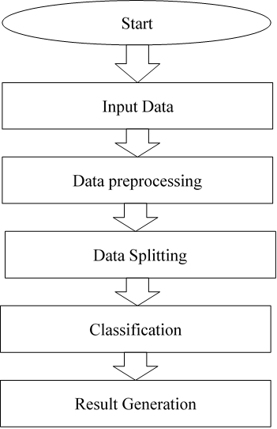

FIGURE 6.1: SYSTEM ARCHITECTURE

6.2 FLOW DIAGRAM:

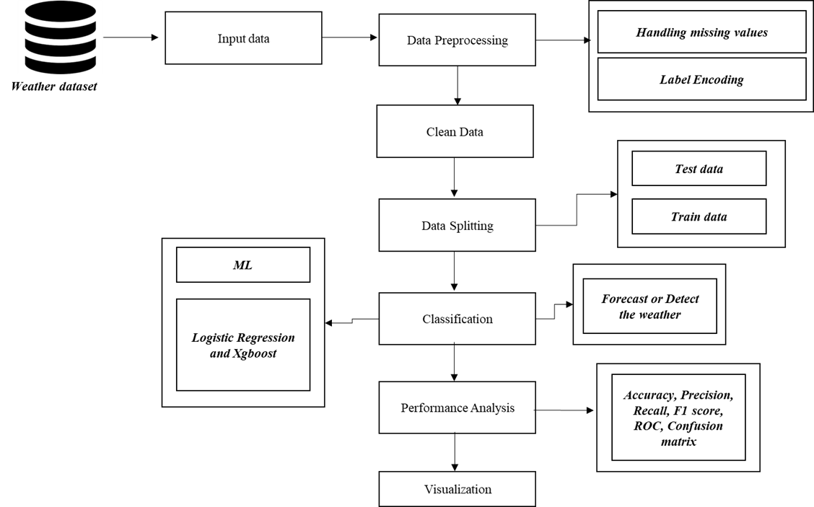

FIGURE 6.2: FLOW DIAGRAM

6.3 UML DIAGRAMS:

6.3.1 USE CASE DIAGRAM:

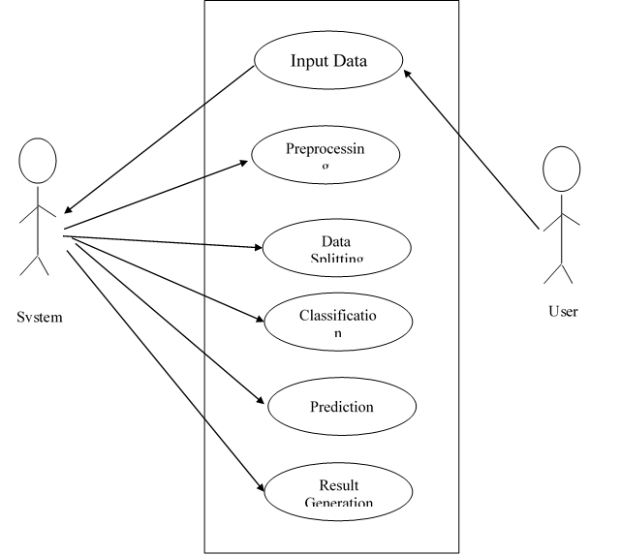

FIGURE 6.3.1: USE CASE DIAGRAM

6.3.2 ACTIVITY DIAGRAM:
Input Image
Preprocessing
Feature Extraction
Performance metrics
Image splitting

Classification

FIGURE 3.3.2: ACTIVITY DIAGRAM

FIGURE 6.3.2: ACTIVITY DIAGRAM

6.3.3 SEQUENCE DIAGRAM:

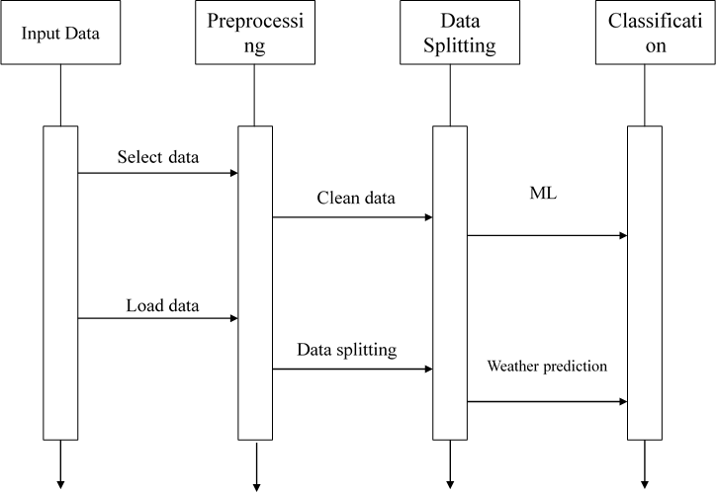

FIGURE 6.3.3: SEQUENCE DIAGRAM

6.3.4 ER DIAGRAM:

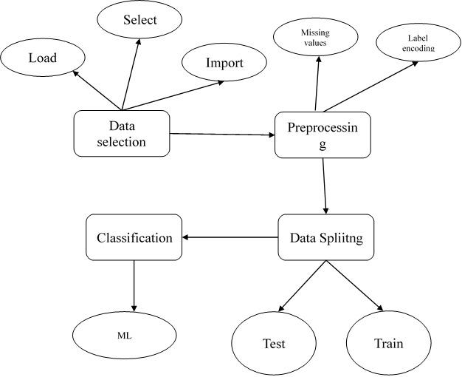

FIGURE 6.3.4: ER DIAGRAM

6.3.5 CLASS DIAGRAM:

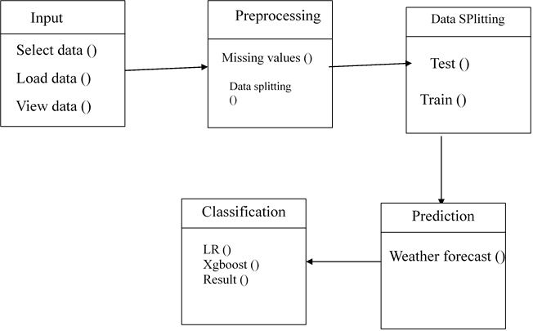

FIGURE 6.3.5: CLASS DIAGRAM

CHAPTER 7

SYSTEM TESTING

7 TESTING PRODUCTS:
System testing is the stage of implementation, which aimed at ensuring that system works accurately and efficiently before the live operation commence. Testing is the process of executing a program with the intent of finding an error. A good test case is one that has a high probability of finding an error. A successful test is one that answers a yet undiscovered error.

Testing is vital to the success of the system. System testing makes a logical assumption that if all parts of the system are correct, the goal will be successfully achieved. . A series of tests are performed before the system is ready for the user acceptance testing. Any engineered product can be tested in one of the following ways. Knowing the specified function that a product has been designed to from, test can be conducted to demonstrate each function is fully operational. Knowing the internal working of a product, tests can be conducted to ensure that “al gears mesh”, that is the internal operation of the product performs according to the specification and all internal components have been adequately exercised.

7.1 UNIT TESTING:

Unit testing is the testing of each module and the integration of the overall system is done. Unit testing becomes verification efforts on the smallest unit of software design in the module. This is also known as ‘module testing’.
The modules of the system are tested separately. This testing is carried out during the programming itself. In this testing step, each model is found to be working satisfactorily as regard to the expected output from the module. There are some validation checks for the fields. For example, the validation check is done for verifying the data given by the user where both format and validity of the data entered is included. It is very easy to find error and debug the system.

7.2 INTEGRATION TESTING:

Data can be lost across an interface, one module can have an adverse effect on the other sub function, when combined, may not produce the desired major function. Integrated testing is systematic testing that can be done with sample data. The need for the integrated test is to find the overall system performance. There are two types of integration testing. They are:
- Top-down integration testing.
- Bottom-up integration testing.

7.3 TESTING TECHNIQUES/STRATEGIES:

- WHITE BOX TESTING:

White Box testing is a test case design method that uses the control structure of the procedural design to drive cases. Using the white box testing methods, we
Derived test cases that guarantee that all independent paths within a module have been exercised at least once.

- BLACK BOX TESTING:

- Black box testing is done to find incorrect or missing function

- Interface error

- Errors in external database access

- Performance errors.

- Initialization and termination errors

In ‘functional testing’, is performed to validate an application conforms to its specifications of correctly performs all its required functions. So this testing is also called ‘black box testing’. It tests the external behaviour of the system. Here the engineered product can be tested knowing the specified function that a product has been designed to perform, tests can be conducted to demonstrate that each function is fully operational.

7.4 SOFTWARE TESTING STRATEGIES

VALIDATION TESTING:

After the culmination of black box testing, software is completed assembly as a package, interfacing errors have been uncovered and corrected and final series of software validation tests begin validation testing can be defined as many,
But a single definition is that validation succeeds when the software functions in a manner that can be reasonably expected by the customer

USER ACCEPTANCE TESTING:

User acceptance of the system is the key factor for the success of the system. The system under consideration is tested for user acceptance by constantly keeping in touch with prospective system at the time of developing changes whenever required.

OUTPUT TESTING:

After performing the validation testing, the next step is output asking the user about the format required testing of the proposed system, since no system could be useful if it does not produce the required output in the specific format. The output displayed or generated by the system under consideration. Here the output format is considered in two ways. One is screen and the other is printed format. The output format on the screen is found to be correct as the format was designed in the system phase according to the user needs. For the hard copy also output comes out as the specified requirements by the user. Hence the output testing does not result in any connection in the system.

CHAPTER 8
SOURCE CODE
import numpy as np
import pandas as pd
import matplotlib.pyplot as plt
import seaborn as sns
from sklearn.ensemble import RandomForestClassifier
from sklearn.model_selection import TimeSeriesSplit
from sklearn.metrics import accuracy_score, classification_report
import pickle

# Load the data
df = pd.read_csv('dataset/seattle-weather.csv') # Replace 'your_dataset.csv' with the actual file path

# Convert the 'date' column to datetime
df['date'] = pd.to_datetime(df['date'])

# Prepare data for modeling
y = df['weather'] # Target variable is changed to 'weather'
X = df[['date', 'precipitation', 'temp_max', 'temp_min', 'wind']]

# Add additional time-related features
X['dayofweek'] = df['date'].dt.dayofweek
X['day'] = df['date'].dt.day
X['month'] = df['date'].dt.month
X['year'] = df['date'].dt.year
# Time Series Split
tscv = TimeSeriesSplit(5)
acc_score = []

# Random Forest Model
for i, (train_ind, test_ind) in enumerate(tscv.split(X)):
X_train, y_train = X.iloc[train_ind], y.iloc[train_ind]
X_test, y_test = X.iloc[test_ind], y.iloc[test_ind]

model = RandomForestClassifier()
model.fit(X_train.drop('date', axis=1), y_train)

y_pred = model.predict(X_test.drop('date', axis=1))
acc = accuracy_score(y_test, y_pred)
acc_score.append(acc)

print(f'{i}th iter:')
print(classification_report(y_test, y_pred))

# Save the model using pickle
with open('model/weather_model.pkl', 'wb') as model_file:
pickle.dump(model, model_file)

# Generating hypothetical future data for prediction
future_dates = pd.date_range(start='2024-03-01', end='2024-03-10', freq='D')
future_precipitation = np.random.uniform(0, 10, size=len(future_dates))
future_temp_max = np.random.uniform(20, 30, size=len(future_dates))
future_temp_min = np.random.uniform(10, 20, size=len(future_dates))
future_wind = np.random.uniform(5, 15, size=len(future_dates))

future_data = pd.DataFrame({
'date': future_dates,
'precipitation': future_precipitation,
'temp_max': future_temp_max,
'temp_min': future_temp_min,
'wind': future_wind
})

# Add time-related features
future_data['dayofweek'] = future_data['date'].dt.dayofweek
future_data['day'] = future_data['date'].dt.day
future_data['month'] = future_data['date'].dt.month
future_data['year'] = future_data['date'].dt.year

# Convert 'date' column to datetime
future_data['date'] = pd.to_datetime(future_data['date'])

# Make predictions
future_data['weather_prediction'] = model.predict(future_data.drop('date', axis=1))

# Data Visualization Graphs

# 1. Line plot for temperature over time
plt.figure(figsize=(12, 6))
sns.lineplot(x='date', y='temp_max', data=df, label='Max Temperature')
sns.lineplot(x='date', y='temp_min', data=df, label='Min Temperature')
plt.title('Temperature Over Time')
plt.xlabel('Date')
plt.ylabel('Temperature')
plt.legend()
plt.savefig('model/1.png')
plt.show()

# 2. Bar plot for precipitation
plt.figure(figsize=(8, 6))
df['month'] = df['date'].dt.month # Add this line to explicitly create a 'month' column
sns.barplot(x='month', y='precipitation', data=df)
plt.title('Monthly Precipitation')
plt.xlabel('Month')
plt.ylabel('Precipitation')
plt.savefig('model/2.png')
plt.show()

# 3. Count plot for weather types
plt.figure(figsize=(8, 6))
sns.countplot(x='weather', data=df)
plt.title('Weather Types Distribution')
plt.xlabel('Weather Type')
plt.ylabel('Count')
plt.savefig('model/3.png')
plt.show()

# 4. Pie chart for the distribution of predicted weather in the future
plt.figure(figsize=(8, 8))
future_data['weather_prediction'].value_counts().plot.pie(autopct='%1.1f%%')
plt.title('Future Weather Predictions Distribution')
plt.savefig('model/4.png')
plt.show()

# 5. Box plot for temperature distribution by month
plt.figure(figsize=(12, 6))
sns.boxplot(x='month', y='temp_max', data=df)
plt.title('Temperature Distribution by Month')
plt.xlabel('Month')
plt.ylabel('Max Temperature')
plt.savefig('model/5.png')
plt.show()

# 6. Pair plot for relationships between numerical features
sns.pairplot(df[['temp_max', 'temp_min', 'precipitation', 'wind']])
plt.suptitle('Pair Plot of Numerical Features', y=1.02)
plt.savefig('model/6.png')
plt.show()

# 7. Heatmap for correlation between numerical features
plt.figure(figsize=(10, 8))
correlation_matrix = df[['temp_max', 'temp_min', 'precipitation', 'wind']].corr()
sns.heatmap(correlation_matrix, annot=True, cmap='coolwarm', fmt=".2f")
plt.title('Correlation Heatmap')
plt.savefig('model/7.png')
plt.show()

# 8. Line plot for future precipitation
plt.figure(figsize=(12, 6))
sns.lineplot(x='date', y='precipitation', data=future_data)
plt.title('Future Precipitation Over Time')
plt.xlabel('Date')
plt.ylabel('Precipitation')
plt.savefig('model/8.png')
plt.show()

# 9. Scatter plot for temperature vs. wind speed
plt.figure(figsize=(10, 6))
sns.scatterplot(x='temp_max', y='wind', data=df, hue='weather')
plt.title('Temperature vs. Wind Speed')
plt.xlabel('Max Temperature')
plt.ylabel('Wind Speed')
plt.savefig('model/9.png')
plt.show()

# 10. Violin plot for temperature distribution by weather type
plt.figure(figsize=(10, 6))
sns.violinplot(x='weather', y='temp_max', data=df)
plt.title('Temperature Distribution by Weather Type')
plt.xlabel('Weather Type')
plt.ylabel('Max Temperature')
plt.savefig('model/10.png')
plt.show()

CHAPTER 9
SAMPLE SCREENSHOT


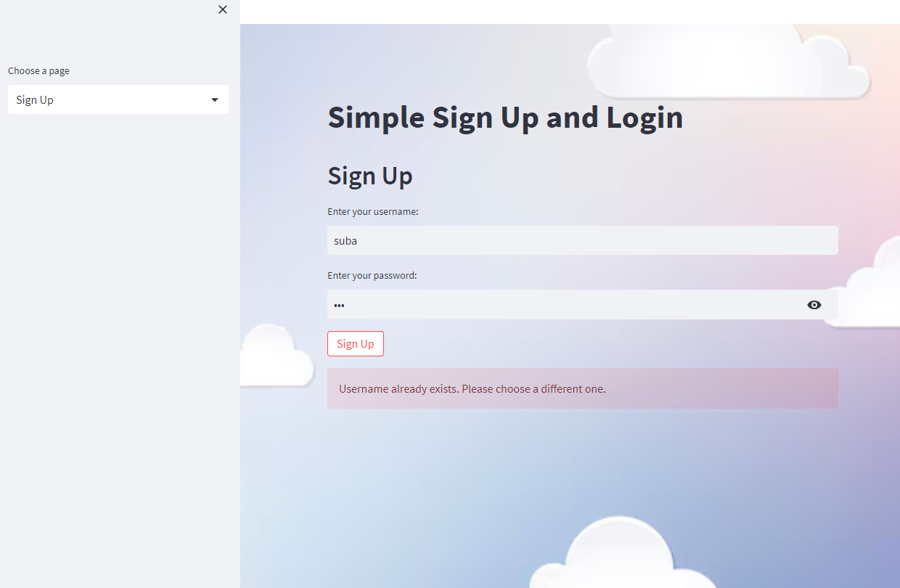

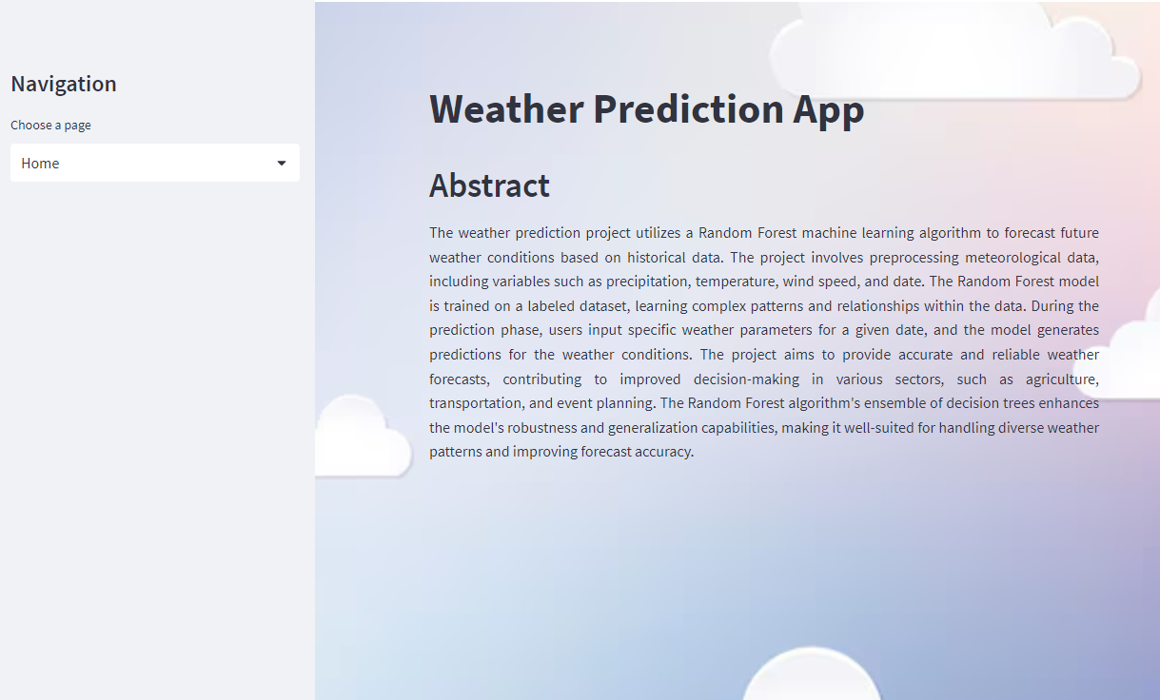

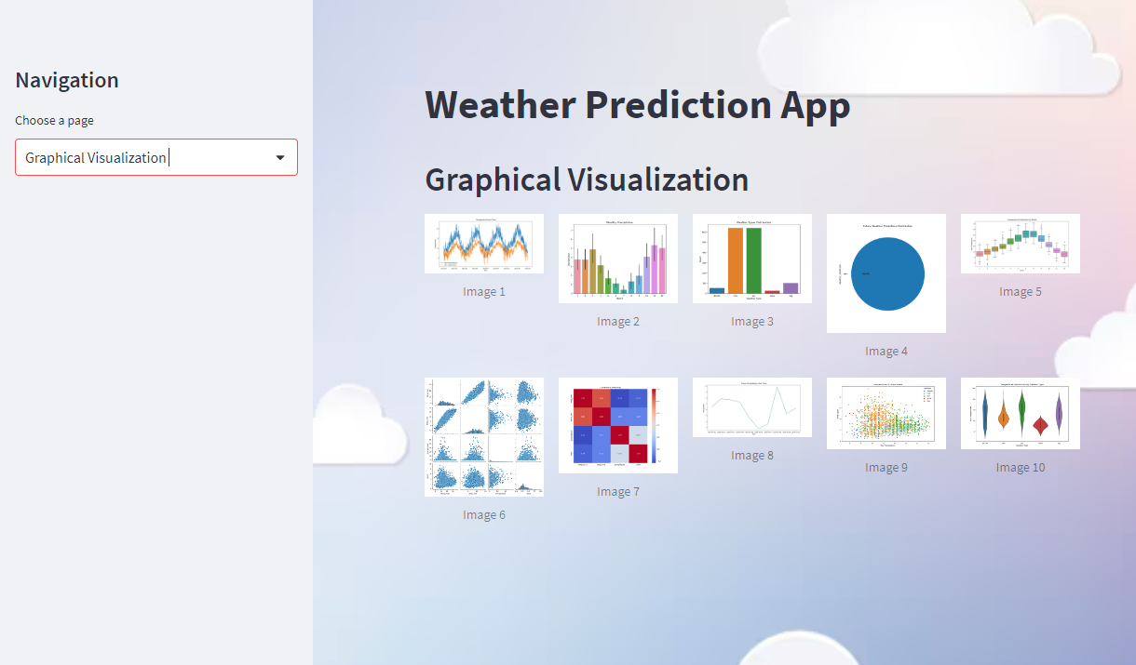

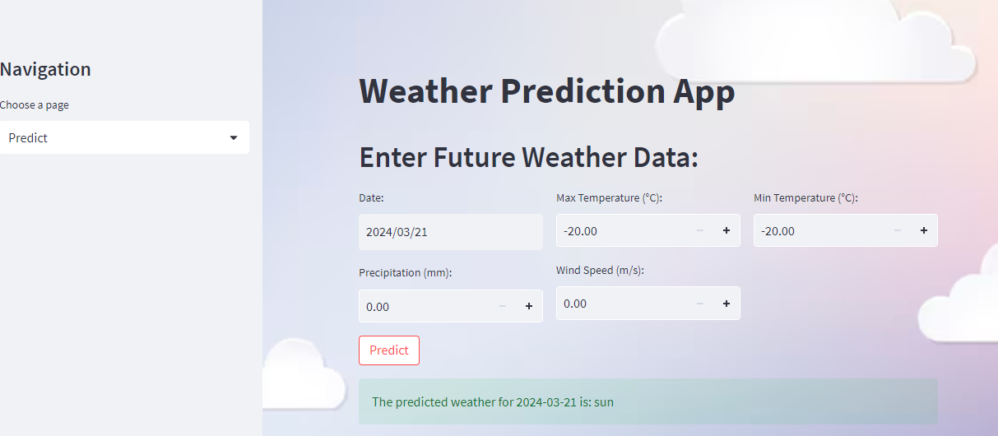

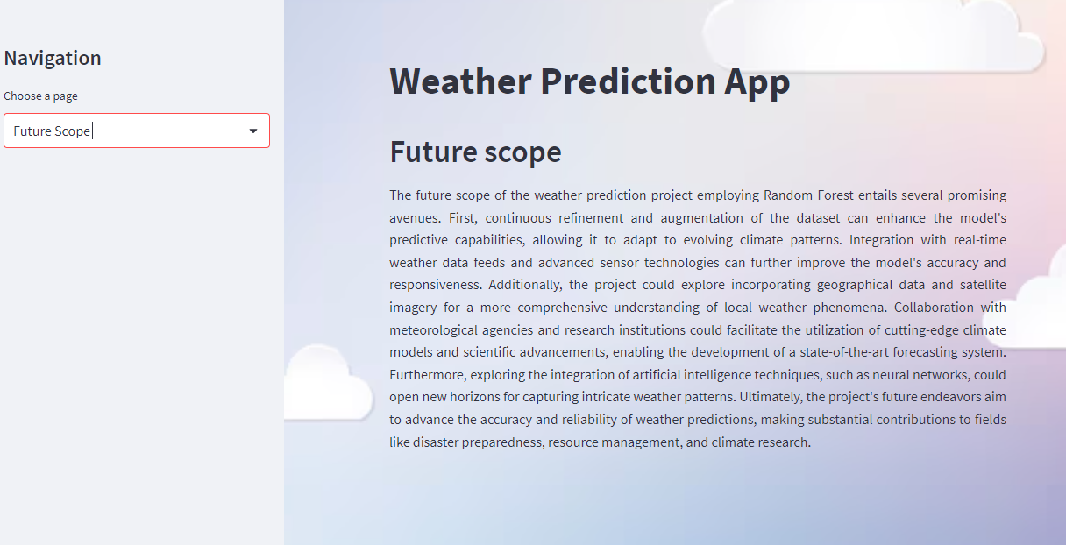
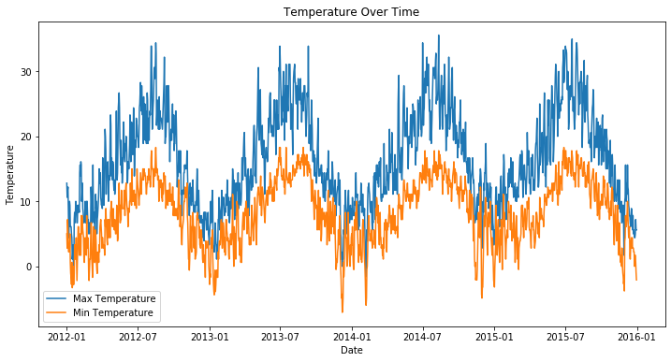
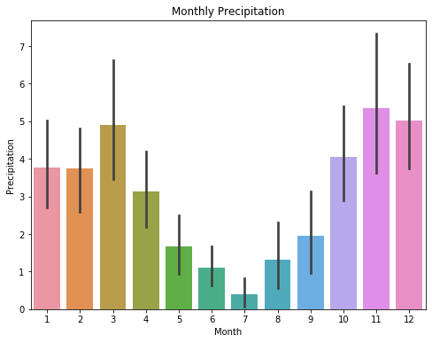

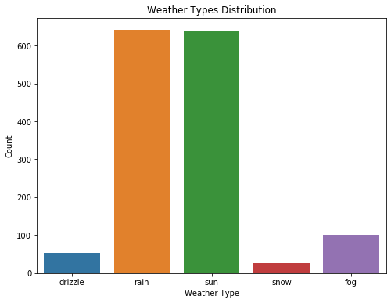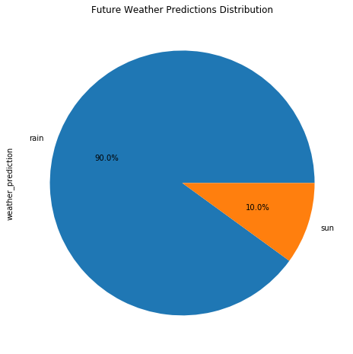
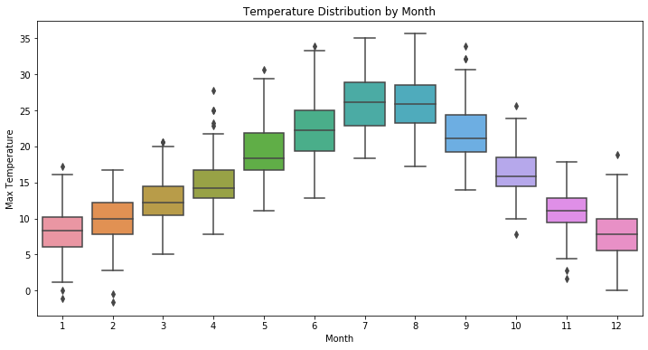
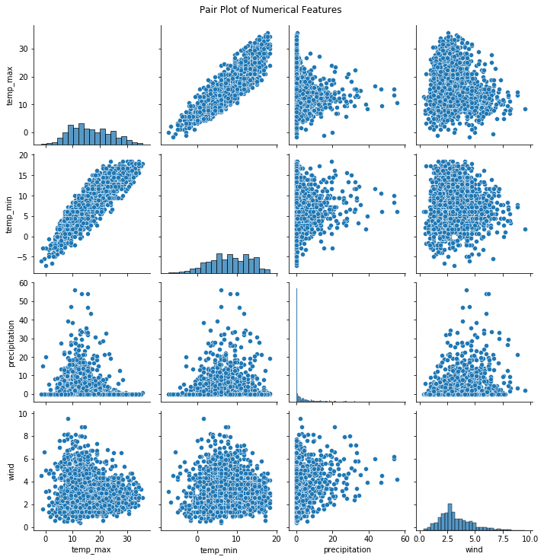
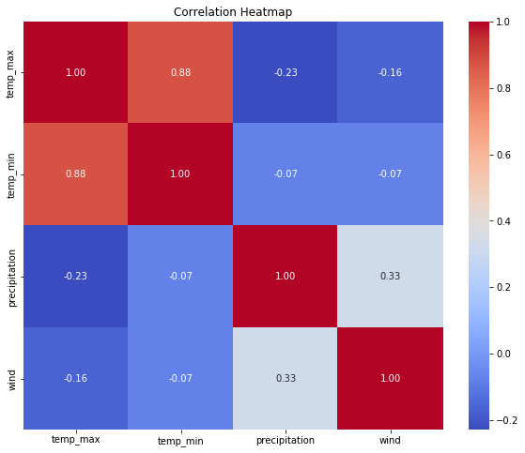
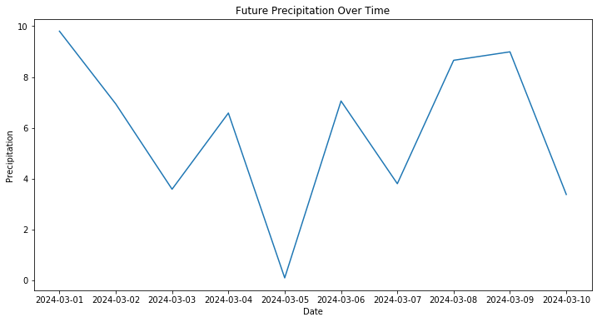
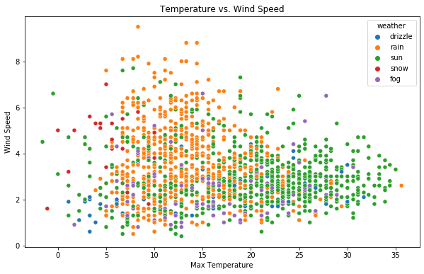
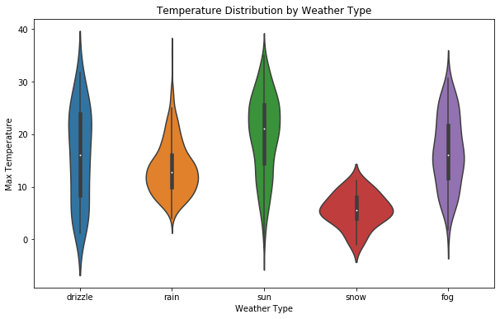

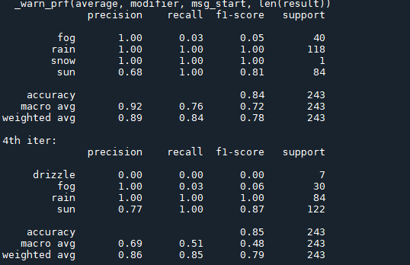

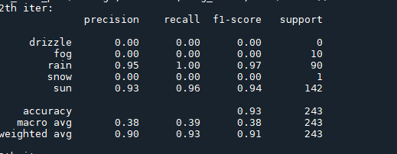

CHAPTER 10
CONCLUSION
This research developed an effective weather forecasting and detection model based on machine learning and deep learning. This system was developed to forecast the weather efficiently utilizing a variety of machine learning algorithms, including logistic regression and KNN. Analysis of the experimental findings demonstrated that, on average, our suggested approach can outperform the current system in terms of performance. As a result, the suggested strategy gives the impression of applying a more comprehensive model for weather forecasting.

CHAPTER 11
FUTURE ENHANCEMENT
We would like to hybridize the two deep learning algorithms or the two machine learning algorithms in the future. To reach even higher performance, the suggested clustering and classification methods may be extended or modified in the future. To increase the detection accuracy, additional combinations and alternative clustering methods can be employed in addition to the tried-and-true combination of data mining approaches.

CHAPTER 12
BIBLIOGRAPHY
1. Imran Maqsood, Muhammad Riaz Khan, and Ajith Abraham. An ensemble of neural networks for weather forecasting, Neural Comput & Applic (2004) 13: 112–122.
2. Ball , R. , Tissot , P. (2006) Demonstration of Artificial Neural Network in Matlab
3. G. R. Gainieva, L. D. Nikitin, M. M. Naimark, N. N. Nazarov, and G. P. Tkachenko, Influence of Batch Composition and Clinkering Properties on the Hot Strength of Coke and Blast-Furnace Operation, ISSN 1068-364X, Coke and Chemistry, 2008, Vol. 51, No. 10, pp. 390–393. © Allerton Press, Inc., 2008
4. http://climate.weatheroffice.gc.ca/climateData/canada_e.html .The website of the weather data of Canada
5. Haider, Adnan and Hanif, Nadeem, M., Inflation Forecasting In Pakistan Using Artificial Neural Networks
6. Matlab 7.6.0 (R2008a), The Math Works Inc., Product Help- Neural Network Toolbox
7. Dr. S. Santhosh Baboo and I.Kadar Shereef. An e_cient weather forecasting system using Artificial neural network. International Journal of Environmental Science and Development, 1(4):321-326, 2010.
8. Amanpreet Kaur, J K Sharma, and Sunil Agrawal. Artificial neural networks in forecasting maximum and minimum relative humidity. International Journal of Computer Science and Network Security, 11(5):197-199, May 2011.
9. Sanjay Mathur, Avinash Kumar, and Mahesh Chandra. A feature based neural network model for weather forecasting, World Academy of Science, Engineering and Technology 34 2007.

10. Mohsen Hayati and Zahra Mohebi. Application of artificial neural networks for temperatureforecasting. World Academy of Science, Engineering and Technology, 28:275{279, 2007.
11. Rosmina Bustami, Nabil Bessaih, Charles Bong, and Suhaila Suhaili. Artificial neural network for precipitation and water level predictions of bedup river. IAENG International Journal of Computer Science, 34(2):228-233, 2007.]
12. Sergio Caltagirone. Air temperature prediction using evolutionary arti_cial neural networks. Master's thesis, University of Portland College of Engineering, 5000 N. Willamette Blvd. Portland, OR 97207, 12 2001.
13. Surajit Chattopadhyay. Multilayered feed forward artificial neural network model to predict the average summer-monsoon rainfall in india. Master's thesis, Department of Mathematics, Techno Model SchoolTechno India Group, EM-4/1, Sector V, Salt Lake, Kolkata 700 091, India, 2006.
14. Tony Hall, Harold E. Brooks, and Charles A. Doswell III. Precipitation forecasting using a neural network, AMS Journal online, Volume 14, Issue 3 (June 1999).
15. N. Q. Hung, M. S. Babel, S. Weesakul, and N. K. Tripathi. An arti_cial neural network model for rainfall forecasting in bangkok, Thailand. Hydrology and Earth System Sciences, 13(8):1413-1425, 2009.
16. Adrian Visoiu. Neural network based model refinement. Informatica Economica Journal,2008.

